WTFC Mission Statement

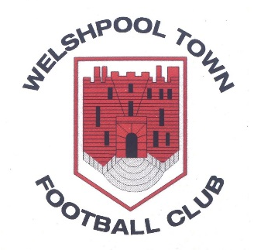

WTFC strives to make a positive contribution to personal, social, technical and tactical development. We aim to instil life skills whilst maximising potential and creating players that can be ‘the best they can be’, in a safe and secure environment.

The football club benefits from a variety of facilities that provide excellent training and competition facilities. The club encourages our players to play attractive, attacking football that is based on possession of the ball, aiming to produce players that can compete at the highest level.

Ultimately WTFC aims to create positive global citizens that will go on to have a positive impact and experience in football and in their community.

