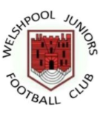
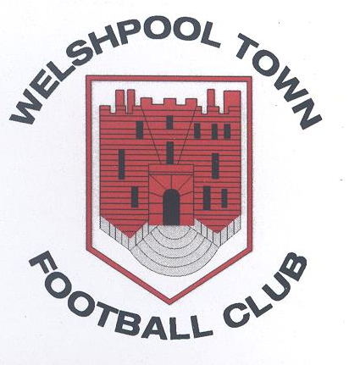Welshpool Town FC & Juniors
PRIVACY NOTICE
Welshpool Town Football Club take your privacy very seriously.

This Privacy Notice sets out how we use and look after the personal information we collect from you. We are the data controller, responsible for the processing of any personal data you give us. We take reasonable care to keep your information secure and to prevent any unauthorised access to or use of it.

What personal data we hold on you
Personal data means any information about an individual from which that individual can be identified.
We collect, use, store and transfer some personal data of our participants and if applicable, their parents or guardians, and other Club members.

You provide information about yourself when you register with the Club, and by filling in forms at an event or online, or by corresponding with us by phone, e-mail or otherwise.

The information you give us may include your name, date of birth, address, e-mail address, phone number, gender, and the contact details of a third party in the case of emergency. We may also ask for relevant health information, which is classed as special category personal data, for the purposes of your health, wellbeing, welfare and safeguarding. Where we hold this data, it will be with the explicit consent of the participant or, if applicable, the participant’s parent or guardian.

Where we need to collect personal data to fulfil Club responsibilities and you do not provide that data, we may not be able honour or administer your membership.

Why we need your personal data
We will only use personal data for any purpose for which it has been specifically provided.

The reason we need your personal data is to be able to run the Club properly, to arrange matches, to administer memberships and provide membership services that you are signing up to when you register with the Club, to ensure that all players are eligible to represent the club and to ensure that the Club is able to comply with all applicable obligations in accordance with the Rules and Regulations of our governing body, the Football Association of Wales (“FAW”). The lawful basis for processing your personal data is that we have a contractual obligation to you as a participant or member to provide the services that you are registering for and/or we have a legitimate interest to ensure that the Club is administered properly and in accordance with the Rules and Regulations of the FAW.
We have set out below, in a table format, a description of all the ways we plan to use your personal data, and which of the legal bases we rely on to do so. We have also identified what our legitimate interests are where appropriate.

Purpose/ Processing Activity | Lawful Basis for processing under Article 6 of the GDPR.
organising matches | Performance of a contract/Legitimate interest
sending out match or Club information and updates | Performance of a contract/Legitimate interest
sharing data with coaches, managers or officials to run training sessions or enter events | Performance of a contract/Legitimate interest
sharing data with leagues we are in membership of, Area Associations, the FAW and any other competition providers where necessary for entry to events/competitions | Performance of a contract/Legitimate interest
sharing data with committee members to provide information about club activities, membership renewals or invitation to social events | The Club has a legitimate interest to maintain member and participant correspondence for club community purposes.
sharing data with third party service or facility providers | The Club has a legitimate interest to run the organisation efficiently and as it sees fit. Provision of some third-party services is for the benefit of the Club, participants and its members.
sharing anonymised data with a funding partner as condition of grant funding e.g. Local Authority | The Club has a legitimate interest to run the organisation efficiently and as it sees fit. Application for funding is a purpose that benefits the Club, participants and its members.
publishing match and league results | Performance of a contract/Legitimate interest – For the purpose of administering leagues and clubs, along with any other competitions
publishing photos of matches and any football related photography and/or videography | Legitimate interest – To run the organisation efficiently and as it sees fit. Where possible and if reasonable grounds are identified, photography/videography can be removed / taken down on the request of those captured. (If under the age of 16, consent from the child and parent/guardian will be required prior to photo/video being published)
To ensure we understand possible health risks | Consent. We will only process details on your medical history with your consent.

Who we share your personal data with
Your personal data may be shared with Leagues, Area Associations, the FAW and First Sports International (who administer on behalf of the FAW the Central Player Registration portal and MyClub portal) in order to ensure that the League is administered properly, that players and Clubs are correctly registered and for affiliation, safeguarding and licensing purposes and to comply with all applicable Rules and Regulations of the FAW.

We may share your personal data with selected third parties, suppliers and sub-contractors such as referees, coaches or match organisers. Third-party service providers will only process your personal data for specified purposes and in accordance with our instructions.

We may disclose your personal information to third parties to comply with a legal obligation; or to protect the rights, property, or safety of our participants, members or affiliates, or others.

The Club’s data processing may require your personal data to be transferred outside of the UK. Where the Club does transfer your personal data overseas it is with the sufficient appropriate safeguards in place to ensure the security of that personal data.

Protection of your personal data
We have put in place appropriate security measures to prevent your personal data from being accidentally lost, used or accessed in an unauthorised way, altered or disclosed.

How long we hold your personal data
We keep personal data on our participants and members while they continue to be a participant or member or are otherwise actively involved with the Club. We will delete this data 1 year after a participant or member has left or otherwise ended their membership or affiliation, or sooner if specifically requested and we are able to do so. We may need to retain some personal data for longer for legal or regulatory purposes. The personal data that is stored on First Sports International is subject to their privacy policy, we advise that you review their policy together with this notice.

Your rights regarding your personal data
As a data subject you may have the right at any time to request access to, rectification or erasure of your personal data; to restrict or object to certain kinds of processing of your personal data, including direct marketing; to the portability of your personal data and to complain to the UK’s data protection supervisory authority, the Information Commissioner’s Office about the processing of your personal data.

As a data subject you are not obliged to share your personal data with the Club. If you choose not to share your personal data with us we may not be able to register or administer your membership.

We may update this Privacy Notice from time to time and will inform you of any changes in how we handle your personal data.

If you have any questions about this Privacy Notice then please contact Eva Bredsdorff, Club Secretary: email: eva.bredsdorff@powys.gov.uk

